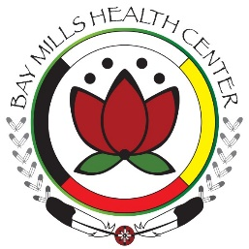

Fall 2022 Flu Vaccine Clinic Schedule

Tuesday, October 11th 2-5pm Horizon’s Conference Center-ADULTS ONLY

Thursday, October 13th 2-5pm Bay Mills Health Center Lobby

Monday, October 17th 11am-2pm Bay Mills Health Center Lobby

Friday, October 28th 2-5pm Bay Mills Health Center Lobby

Thursday, November 3rd 2-5pm Drive-Thru Clinic @ Armella Parker Senior Center

Tuesday, December 6th 11am-2pm Bay Mills Health Center Lobby

*Moderna Bivalent COVID-19 boosters will also be available at these clinics.

**Please note these clinics are subject to last minute cancelation/change based on vaccine availability.

